**Cluster Centers**

|  |  |
| --- | --- |
| **Cluster #** | **Cluster Center:** *totalAdClicks , totalGameClicks , revenue* |
| 0 | 24.99 , 357.96 , 35.07 |
| 1 | 36.44 , 926.12 , 46.97 |
| 2 | 32.36 , 2310.64 , 39.42 |

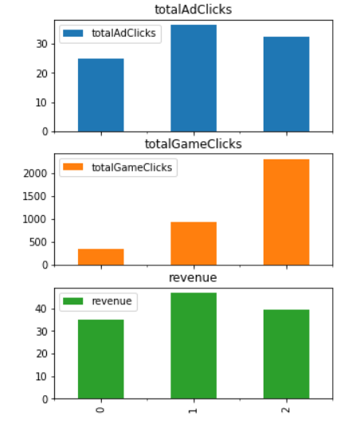

Cluster 0: Customers that don’t play much but still generate some revenue

Cluster 1: Customers that are very cash convertible with ads even if they play a moderate amount, generating a high amount of revenue

Cluster 2: Customers that are very active and generate a moderate amount of revenue